﻿Example Excel File Input:

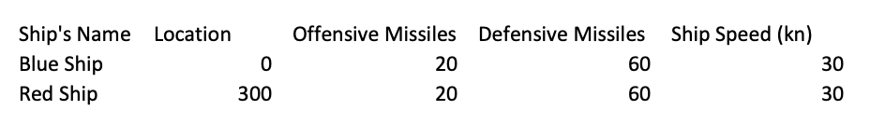

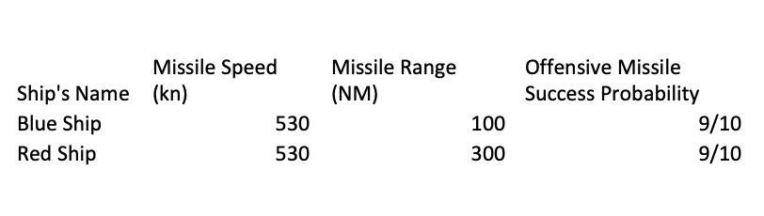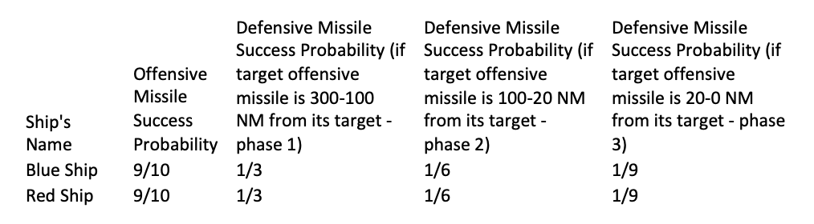

Example Output:

Time Elapsed: 201.25

Red Ship:

Ship has not been hit

Current best known location is 300 NM on the 1D scale

9 offensive missiles already fired

11 offensive missiles left in ship's arsenal

0 defensive missiles already fired

60 defensive missiles left in ship's arsenal

Blue Ship:

The ship has been hit!!

Current best known location is 100.75 NM on the 1D scale

0 offensive missiles already fired

20 offensive missiles left in ship's arsenal

60 defensive missiles already fired

0 defensive missiles left in ship's arsenal

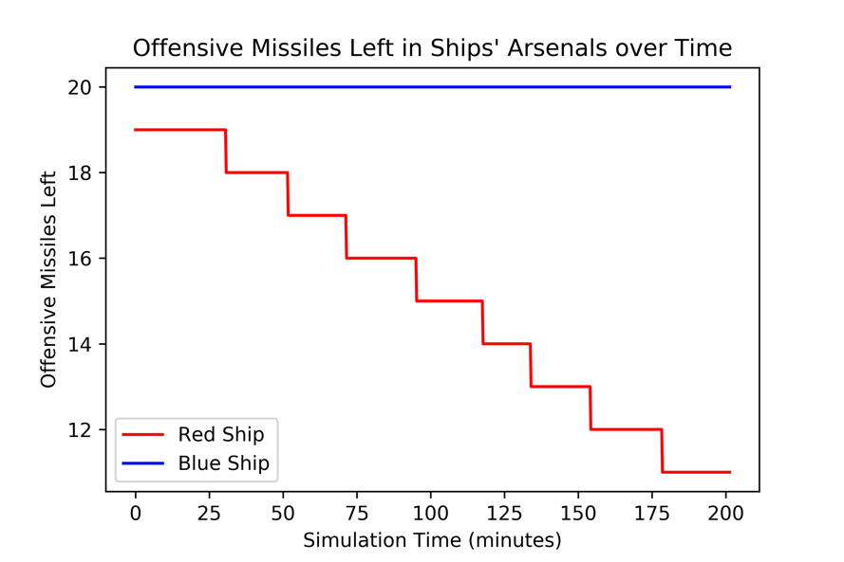

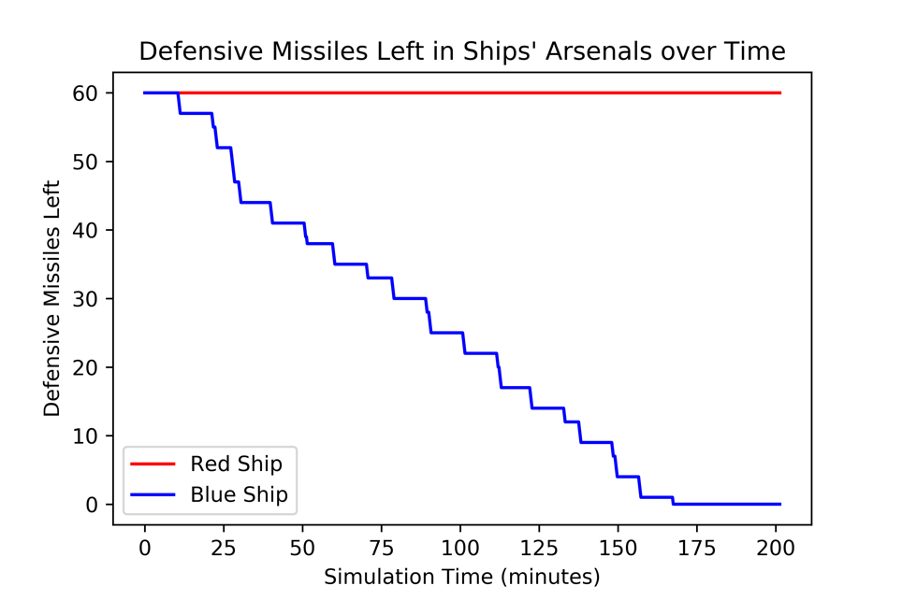

Example Simulation Beginning Visual:

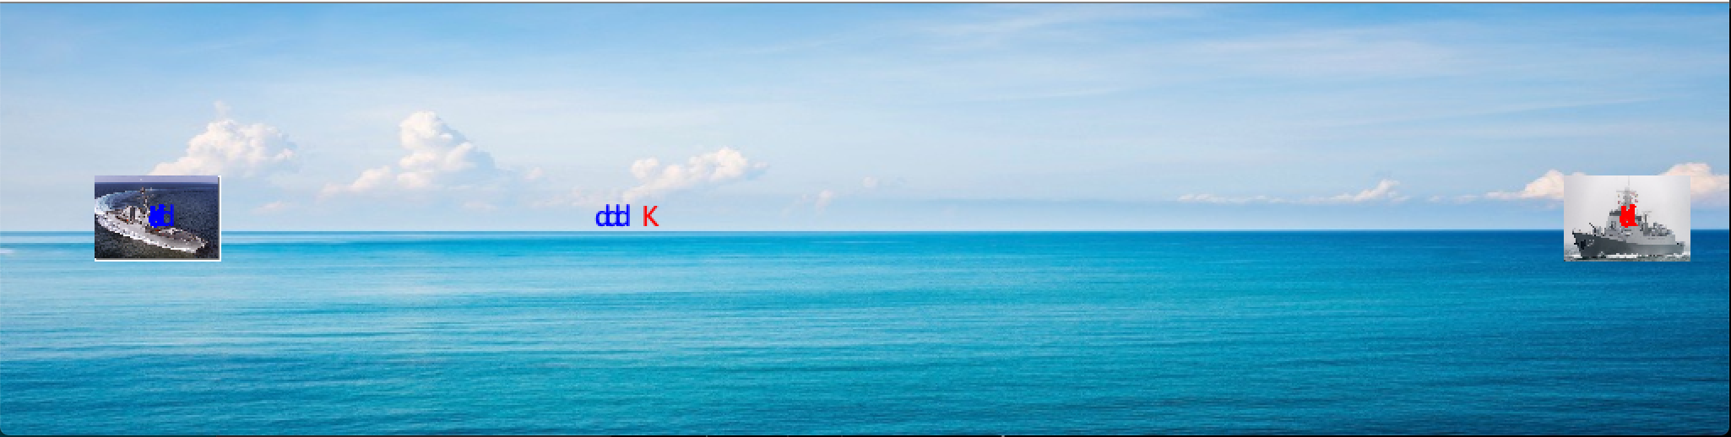

Example Simulation Ending Visual:

